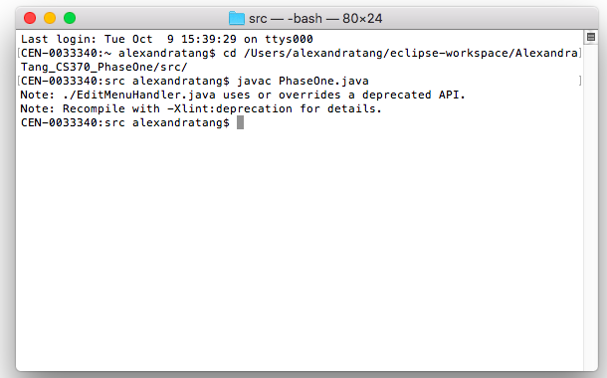**USER MANUAL**

1. Navigate to the directory with the files.  
   As shown above, that can be done by typing the following command: “cd [insert path here]”.  
   Hit ‘Enter’ when ready.
2. Compile the program by typing “javac PhaseOne.java”.  
   Hit ‘Enter’ when ready. You should receive the two notes, like above.

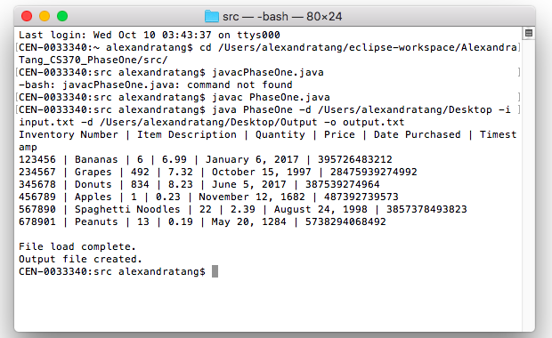

1. To complete different tasks, type “java PhaseOne [UNIX flag] [argument]”.  
   Here, four flags are used in one line:  
    -d /Users/alexandratang/Desktop → sets the path to /Users/alexandratang/Desktop  
    -i input.txt → reads in an input file at the location given by the path set above  
    -d /Users/alexandratang/Desktop/Output → sets the path to /Users/alexandratang/Desktop/Output  
    -o output.txt → saves an output file named “output.txt” at the location above  
     
   The result of this command can be seen on the following page.  
     
   To learn more about the different UNIX flags and how to use them, please refer to the included Readme.txt file.

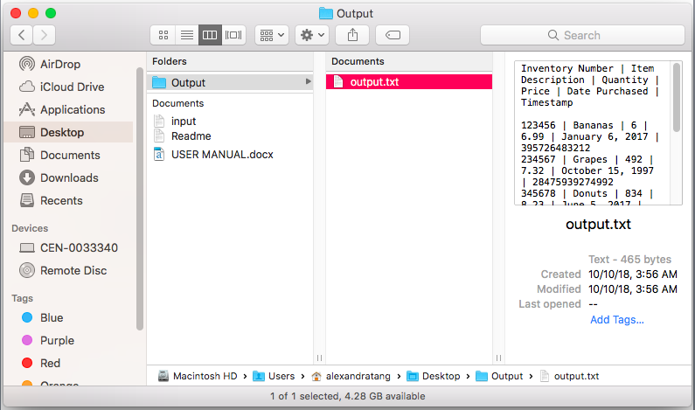

Here we can see:

The input folder accessed is at /Users/alexandratang/Desktop.  
 An output file is created at /Users/alexandratang/Desktop/Output.

**A GUI IMPLEMENTATION**

1. To use the GUI implementation, type in “java PhaseOne –g”.  
   Hit ‘Enter’ when ready.

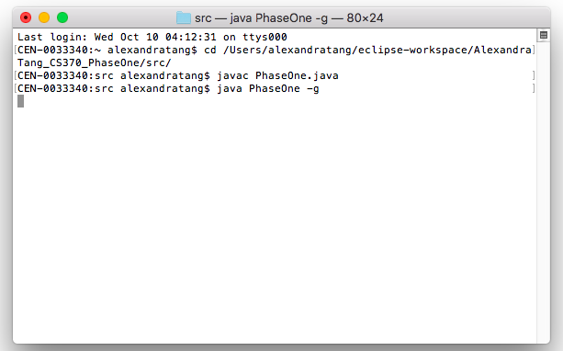

1. 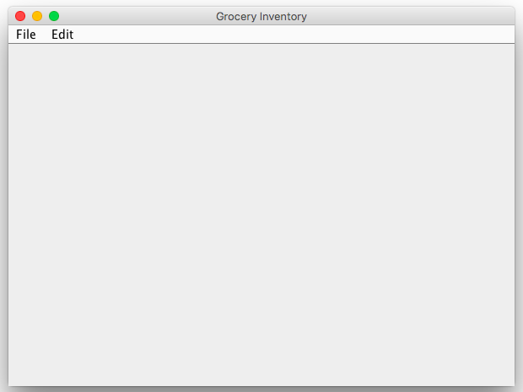This will open a GUI like so.
2. From here, you can access the File Menu.  
   In the File Menu, you can open files, save your file, and view your log file.

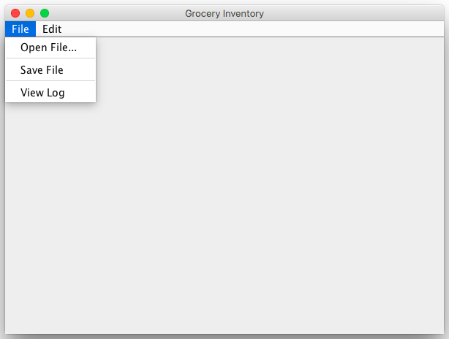

1. Similarly, you can also access the Edit Menu.  
   In the Edit Menu, you can add products, edit products, and remove products.

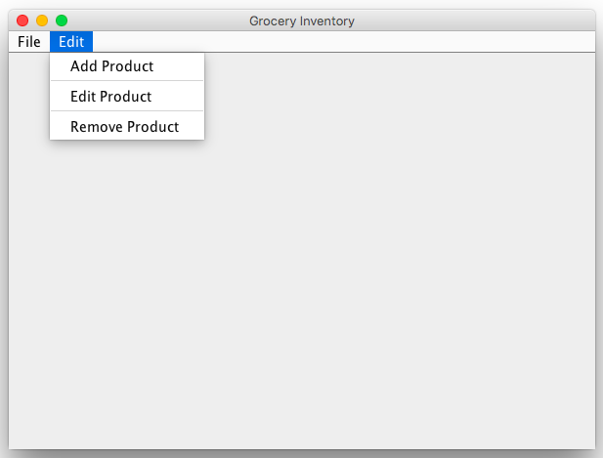

**OPENING INPUT FILES**

1. In the File Menu, upon pressing Open File…, a JFileChooser will appear and you can browse through your folders to find your input file.  
   Once located, click it and press ‘Open’.

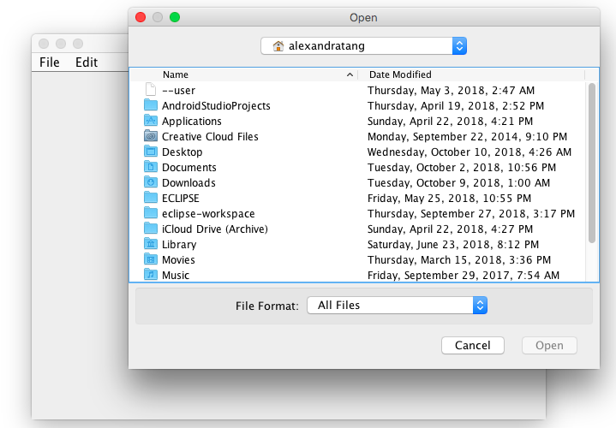

1. Once fully loaded, you will receive a message indicating so.

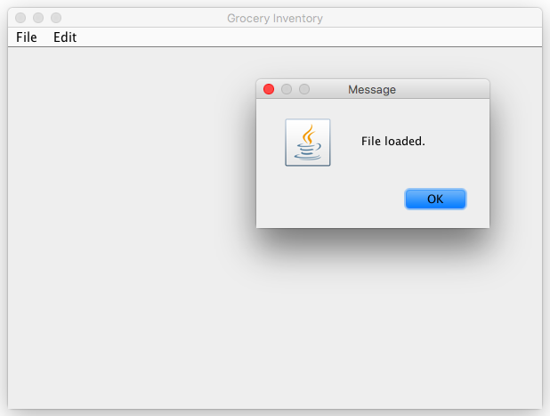

**SAVING FILES/CREATING OUTPUT FILES**

1. In the File Menu, after opening a file, you are now able to save files/create output files.  
   Press ‘Save File’ to begin the process. You will receive a prompt asking you to name your output file.
2. Enter whatever name you please following the format: filename.txt.  
   Hit ‘OK’ when ready.
3. You will receive a prompt saying your file has been saved.

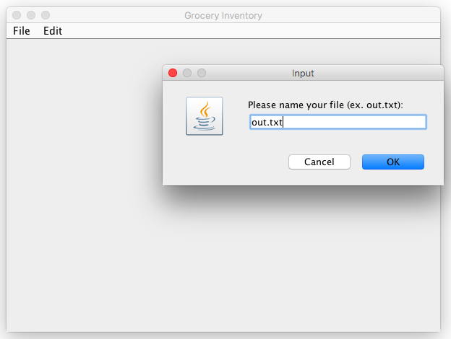

1. Your file will be saved in the directory you are currently in (the one in which the program files are saved).  
   Note: You can save to another directory by adding a path before your output file name in the input prompt.  
    Ex: “/users/alexandratang/Desktop/out.txt”

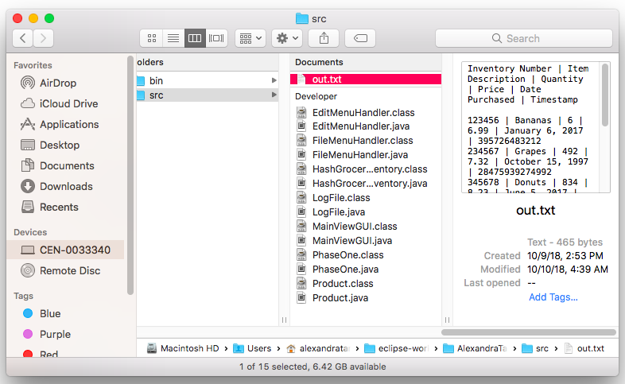

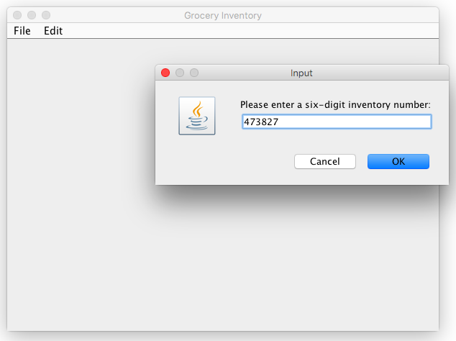**ADDING PRODUCTS**

1. In the Edit Menu, after pressing ‘Add Product’, this prompt will appear and you can enter a six-digit inventory number. If the number already exists, a prompt will appear saying so.

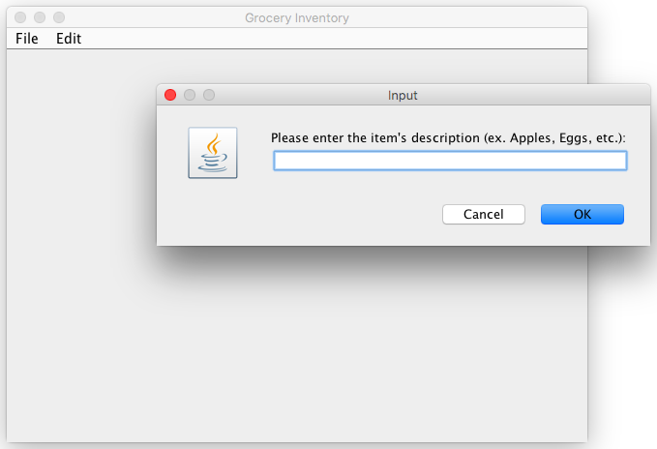

2. After successfully entering a new inventory number, you will be prompted for an item description, then a quantity, then a price, then a date of purchase, then a timestamp. A prompt will then appear saying you have successfully added a product. This product will be in your inventory now and can be viewed by saving the file and viewing your new output file.

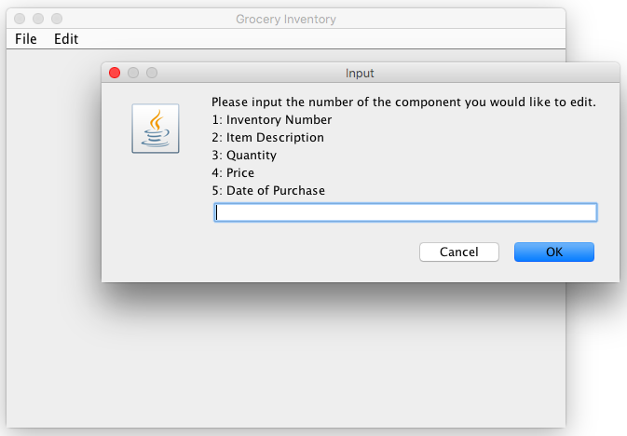**EDITING PRODUCTS**

1. Upon pressing ‘Edit Products’ in the Edit Menu, this prompt will appear, asking you to input the number of the component you’d like to edit.

*EDITING INVENTORY NUMBERS*

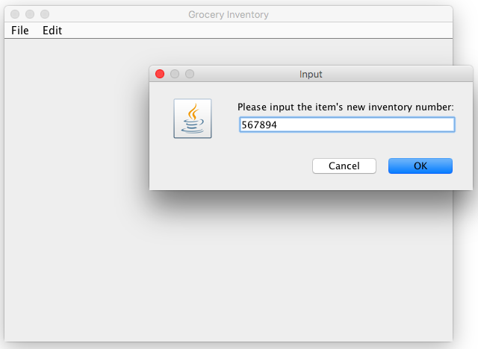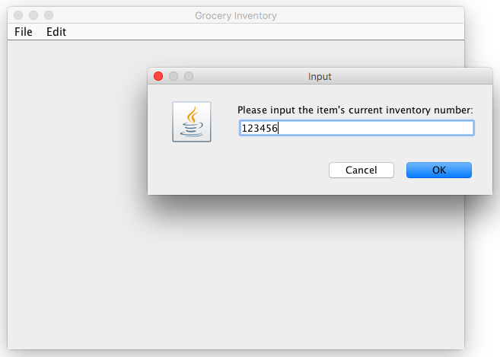

1. In the photo on the left, you’ll first receive a prompt asking for your item’s current inventory number.
2. In the photo on the right, you’ll receive a prompt asking for the new inventory number.
3. If neither inventory numbers cause an error (the current inventory number not existing and the new inventory number already existing), you will receive a prompt saying your product has been added. The changes will be seen in your log and output files.

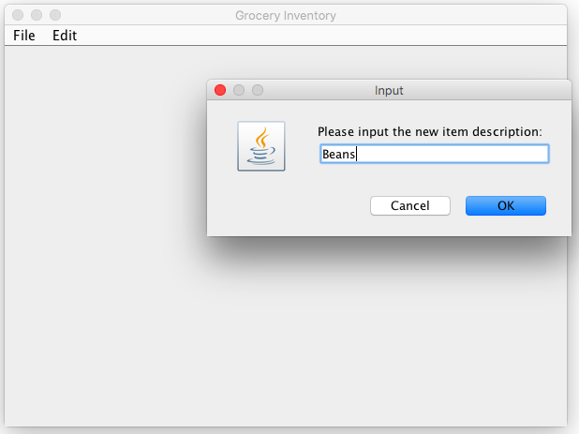*EDITING ITEM DESCRIPTIONS / QUANTITY / PRICE / DATE OF PURCHASE*

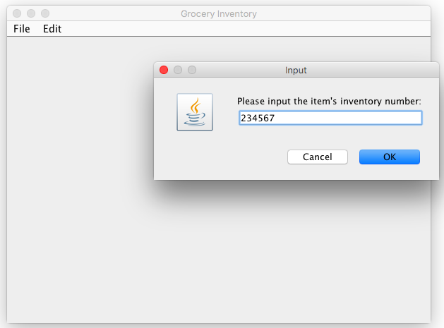

1. In the photo on the left, you’ll first receive a prompt asking for your item’s current inventory number.
2. In the photo on the right, you’ll receive a prompt asking for the new item description / quantity / price /date or purchase.
3. If current inventory number does not cause an error (by not existing), you will receive a prompt saying your product has been successfully edited. The changes can be seen in your log and output files.

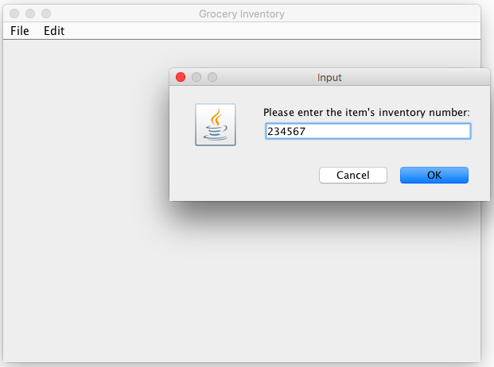**REMOVING PRODUCTS**

1. In the Edit Menu, after pressing ‘Remove Product’, this prompt will appear and you can enter a six-digit inventory number. If the number does not exist in the inventory already, a prompt will appear saying so.

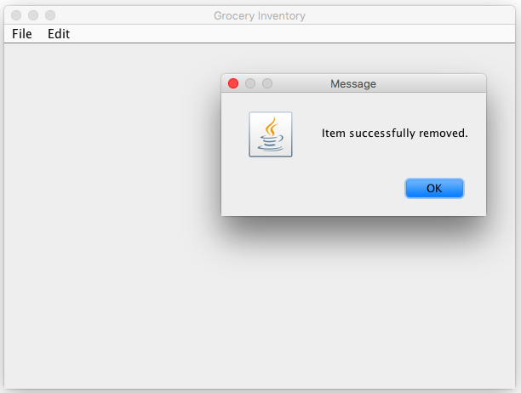

2. After successfully entering an inventory number, you will receive a prompt saying you have successfully removed the product. This product will no longer be in your inventory and will not be seen in your output file.

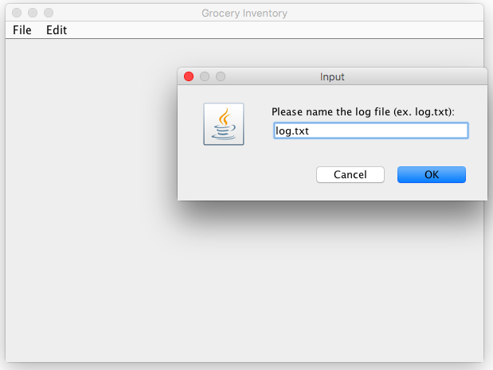**VIEWING LOG FILES**

1. Similar to creating output files, you will be asked to name your log file. A path can be added prior to your file name as mentioned earlier to save it to a specific destination. You will receive a prompt saying log updates are complete.

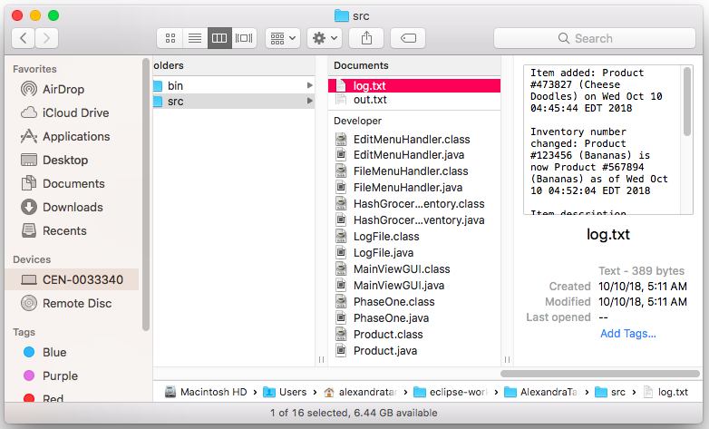

2. Your file will be saved in the directory you are currently in (the one in which the program files are saved) unless you provided a path earlier.